Bridging Rental Assistance Program (BRAP)
Monitoring Report
Quarter 2 FY2014 (October, November, December 2013)

The Bridging Rental Assistance Program (BRAP) has been established in recognition that recovery can only begin in a safe, healthy, and decent environment, a place one can call home. The Office of Substance Abuse and Adult Mental Health Services recognizes the necessity for rental assistance for persons with mental illness, particularly those being discharged from hospitals, group homes, homeless shelters,and places considered substandard for human habitation. There is not a single housing market in the country where a person receiving Social Security as his or her sole income source can afford to rent even a modest one-bedroom apartment. According to a report issued by the Technical Assistance Collaborative, Priced out in 2012 in Maine, 95% of a person’s SSI standard monthly payment is needed to pay for the average one-bedroom apartment statewide. In Cumberland County the amount is 94% and Sagadahoc 98%. In the City of Portland 115% of a person’s SSI is necessary to pay for the average one-bedroom apartment and in the KEYS area (Kittery, Elliot, York and South Berwick) 110%.
BRAP is designed to assist individuals who have a psychiatric disability with housing costs for up to 24 months or until the individuals are awarded a Housing Choice Voucher (aka Section 8 Voucher), another federal subsidy, or until the individuals have an alternative housing placement. All units subsidized by BRAP funding must meet the U.S. Department of Housing and Urban Development’s Housing Quality Standards and Fair Market Rents. Following a Housing First model, initial BRAP recipients are encouraged, but not required to accept the provision of services to go hand in hand with the voucher.
The monitoring of the Bridging Rental Assistance Program (BRAP) is the responsibility of the Office of Substance Abuse and Adult Mental Health Services (SAMHS) and particularly the Data, Quality Management, and Resource Development team.

The bullets below highlight some of the details regarding persons who are currently waiting for a BRAP voucher: The percentage terms reflect the percentage of relative change compared to the last report. As is reflected by the bullets below (see table and graph on last page), the BRAP program has made very efficient utilization of the influx of funds in this fiscal year in the last 6 months.

- Priority #1 applicants (Discharge from a psychiatric hospital within the last 6 months). Riverview and Dorothea Dix consumers are typically not waiting more than 5 days from the date of a completed application. Priority 1 applicants waiting for a BRAP voucher have increased from 1 to 2 persons, up 100%--both of these persons have vouchers reserved for them upon discharge.
- Priority #2 applicants (Homeless) have decreased from 92 to83 persons down 10%
- Priority #3 applicants (Substandard Housing) remains at 3 persons.
- Priority #4 applicants (Community Residential Facility) have also increased from 9 to 10 persons, up 10%.
- Persons on the waitlist greater than 90 days have remained the same at16—we are following up on all of these individuals to confirm their status.

Since inception of the wait list, there has been a total of 2,668 BRAP vouchers awarded broken down as follows: Priority #1, 1,210; Priority #2, 1,171; Priority #3, 36; Priority #4, 236. Note that 15 vouchers have been awarded to persons with no priority. In the last quarter 218 vouchers were awarded.

The current BRAP census as of December 31, 2013 is 1,142 vouchers issued well above our targeted goal of 930 vouchers. Due to management of voucher funding we have been able to house well above that amount—resulting in a decreasing waitlist. However despite the steady increase in vouchers issued, our waitlist is projected to climb over the next two quarters as the census levels out. The overall budget for FY 14 increased to $5,018,508 which is allowing us to better meet the waitlist needs and push for expansion into more rural areas where vouchers have not been traditionally utilized due to housing stock as well as community education and partnership. This is being done through our established administrative agents as well as the developing relationships with the PATH program, Continuums of Care, and Homeless Councils. We now have several persons housed in Washington county and continue to address the more rural parts of the State through partnering with the previously mentioned groups as well as using our existing, contracted LAA’s for reaching out to those communities. Our office has met with these agencies with specific goals of increasing utilization where the clients are, rather than where the vouchers can be used by quickly finding new resources and increasing community education and partnerships.

The number of persons on the program for greater than 24 months remains 50% of the entire program. This is principally a result of decades of federal and state cuts to low-income and supportive housing programs, including persons who will not qualify for Section 8 due criminal activity. The lack of availability of these resources, particularly Section 8 at the federal level, has translated to increased pressures on state programs such as BRAP.

SAMHS administers a substantial number of Shelter Plus Care vouchers, more than any other state on a per-capita basis. The census was 889 as of December 31, 2013. This program is funded by the U.S. Department of Housing and Urban Development and has seen significant growth over the last decade, the result of SAMHS aggressively applying for and receiving new grants each year. It should be noted that HUD has eliminated new project funding through an overall reduction of over 5% in this latest funding round. Shelter Plus Care has retained it’s existing funding however no new SPC applications have been submitted. The FY2014 annual budget for Shelter Plus Care is $7.9 million. The total dollars for all SPC grants (one year renewals to 5 year new contracts) administered by SAMHS is $14,101,781. Shelter Plus Care (SPC) provides permanent rental subsidies (housing vouchers) and supportive services (provided by MaineCare) to literally homeless individuals with: severe and persistent mental illness (63%), chronic substance abuse and mental illness (30%), and chronic substance abuse and HIV/AIDS (7%).

BRAP Waitlist Status--Graph:
Detail by Priority Status to include those persons waiting longer than 90 Days
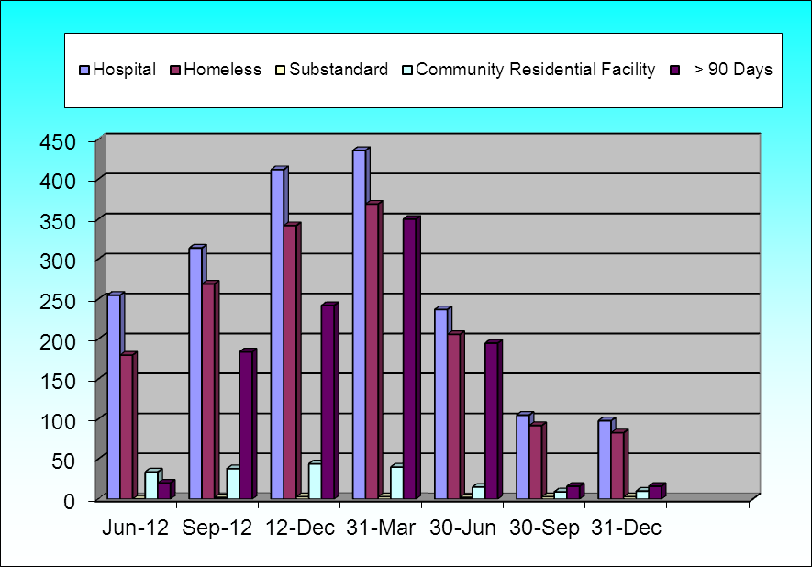

BRAP Waitlist Status—Table:
Detail by Priority Status to include those persons waiting longer than 90 Days
Reporting Period | Jun-12 | Sep-12 | 12-Dec | 31-Mar | 30-Jun | 30-Sep | 31-Dec |  | % Change relative to Last Report
Total number of persons waiting for BRAP | 255 | 314 | 412 | 436 | 237 | 105 | 98 |  | -7%
Priority 1—Discharge from state or private psychiatric hospital within last 6 months | 41 | 5 | 23 | 22 | 12 | 1 | 2 |  | 100%
Priority 2—Homeless (HUD Transitional Definition) | 180 | 269 | 342 | 369 | 206 | 92 | 83 |  | -10%
Priority 3—Sub-standard Housing | 0 | 2 | 3 | 3 | 2 | 3 | 3 |  | 0%
Priority 4—Leaving a Community Residential living facility | 34 | 38 | 44 | 40 | 15 | 9 | 10 |  | 10%
Total number of persons on wait list more than 90 days awaiting voucher | 20 | 184 | 242 | 350 | 195 | 16 | 16 |  | 0%

*Note: Both Priority #1 persons are in mental health facilities awaiting discharge—vouchers are dedicated to these persons when ready

BRAP Awards—Graph
Cumulative Since Inception of Waitlist
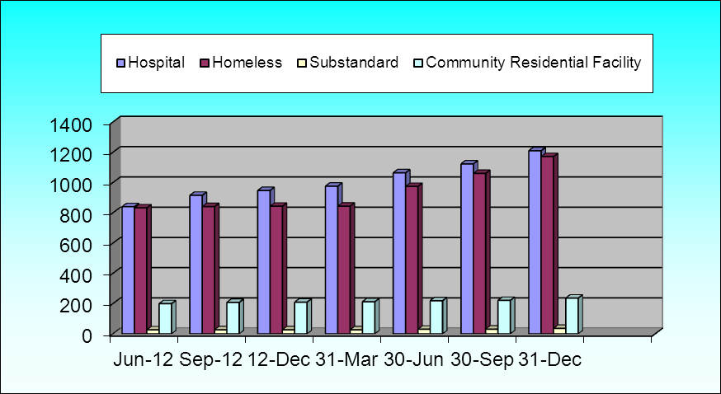

BRAP Awards—Table
Cumulative Since Inception of Waitlist
Reporting Periods | Jun-12 | Sep-12 | 12-Dec | 31-Mar | 30-Jun | 30-Sep | 31-Dec |  | % Change relative to Last Report
Cumulative number of persons awarded BRAP | 1908 | 2003 | 2038 | 2071 | 2300 | 2450 | 2668 |  | 8%
Priority 1—Discharge from state or private psychiatric hospital within last 6 months | 840 | 915 | 947 | 976 | 1064 | 1123 | 1210 |  | 7%
Priority 2—Homeless (HUD Transitional Definition) | 832 | 841 | 843 | 844 | 974 | 1060 | 1171 |  | 9%
Priority 3—Sub-standard Housing | 26 | 27 | 27 | 27 | 30 | 31 | 36 |  | 14%
Priority 4—Leaving a DHHS funded living facility | 199 | 208 | 209 | 212 | 219 | 221 | 236 |  | 6%

*Note: 15 persons awarded with no priority

